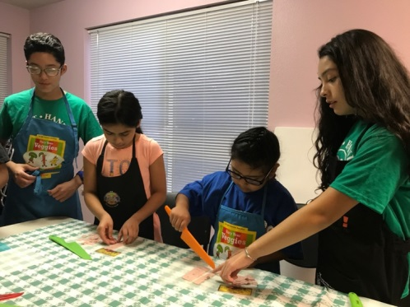
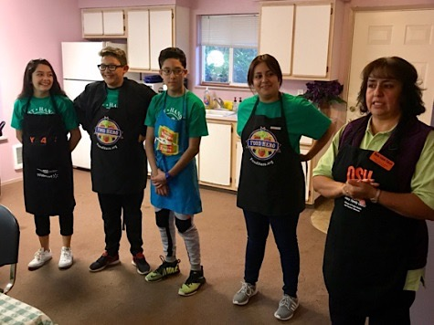
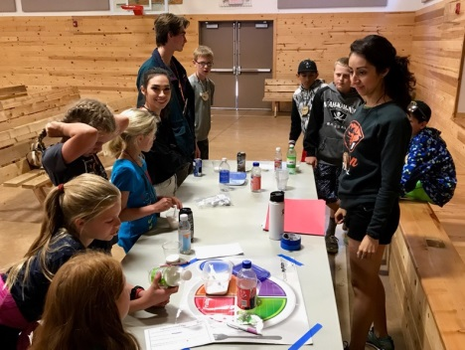
Oregon State University Extension Service delivers PAN programming to youth throughout Yamhill County. We integrate PAN concepts through education and activity.
But what EXACTLY do you do?
  - We teach kids how to choose healthy foods and
be physically active.
  - We read fun stories, play active games, and
try new foods, including Food Hero recipes!
  - Our lessons are short and age-appropriate.
  - We run after-school clubs, summer camps, and classroom lessons that utilize USDA’s common-core aligned curriculums.
  - We are looking to EXPAND our scope and would love to PARTNER with you at your site!
Do you want to partner with us?
Contact Mike Knutz at (503) 434-8913 for more Information!
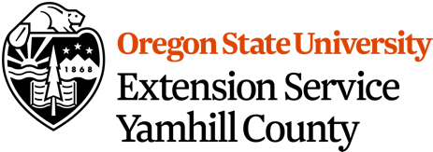

This material was funded in part by USDA’s Supplemental Nutrition Assistance Program (SNAP). SNAP provides nutrition assistance to people with low income. SNAP can help you buy nutritious foods for a better diet. To find out more, contact Oregon Safe Net at 211. USDA is an equal opportunity provider and employer. Oregon State University Extension Service prohibits discrimination in all its programs, services, activities, and materials on the basis of race, color, national origin, religion, sex, gender identity (including gender expression), sexual orientation, disability, age, marital status, familial/parental status, income derived from a public assistance program, political beliefs, genetic information, veteran’s status, reprisal or retaliation for prior civil rights activity. (Not all p prohibited bases apply to all programs.) Oregon State University, Oregon State University Extension Service and Food Share of Lincoln County are Equal Opportunity Providers. Accommodation requests related to a disability or dietary r restriction should be made by September 18th to Stephanie Russell by calling 541-574-6534 (ext. 57425) or by emailing Stephanie.Russell@oregonstate.edu

