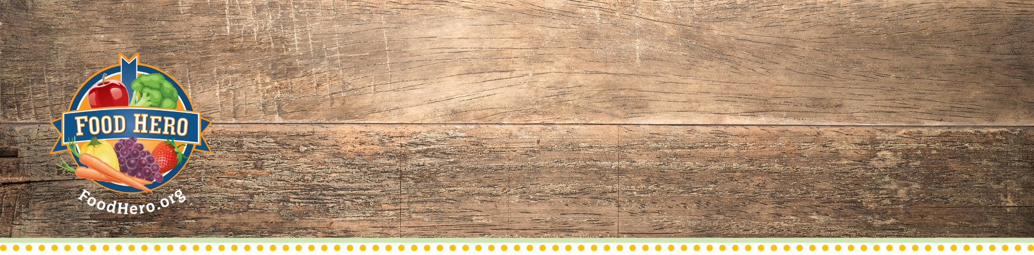
Directions to Kids Art Contest
Food Hero/Blue Zones Project Kids Art Contest Directions

All Kids Art Contest files can be found in the Food Hero Community Toolkit: http://foodhero.org/kids-art-contest Questions? Email Us: food.hero@oregonstate.edu

When and Where:
Turn in your artwork to the front office by November 6th.
Prizes:
There will be a 1st place prize for each grade level.
You could win a Blue Zones t-shirt, beanie, or sunglasses!
1st place for the school will be displayed on the Food Hero Bulletin Board.
Some tips:
- Try showing bell peppers, potatoes, cherries, cucumbers, pumpkins, summer squash, parsnips, cauliflower, or anything related to gardening.
- We love color—even in the background.
- Surprise us with different art forms—collage, watercolor, pastels, colored pencils, crayons, etc.
- It’s fine to have a few words on your art, but avoid a lot of writing, because it can be distracting.
- Use 8 ½ x 11 paper, turned horizontally (landscape) or vertically (portrait).
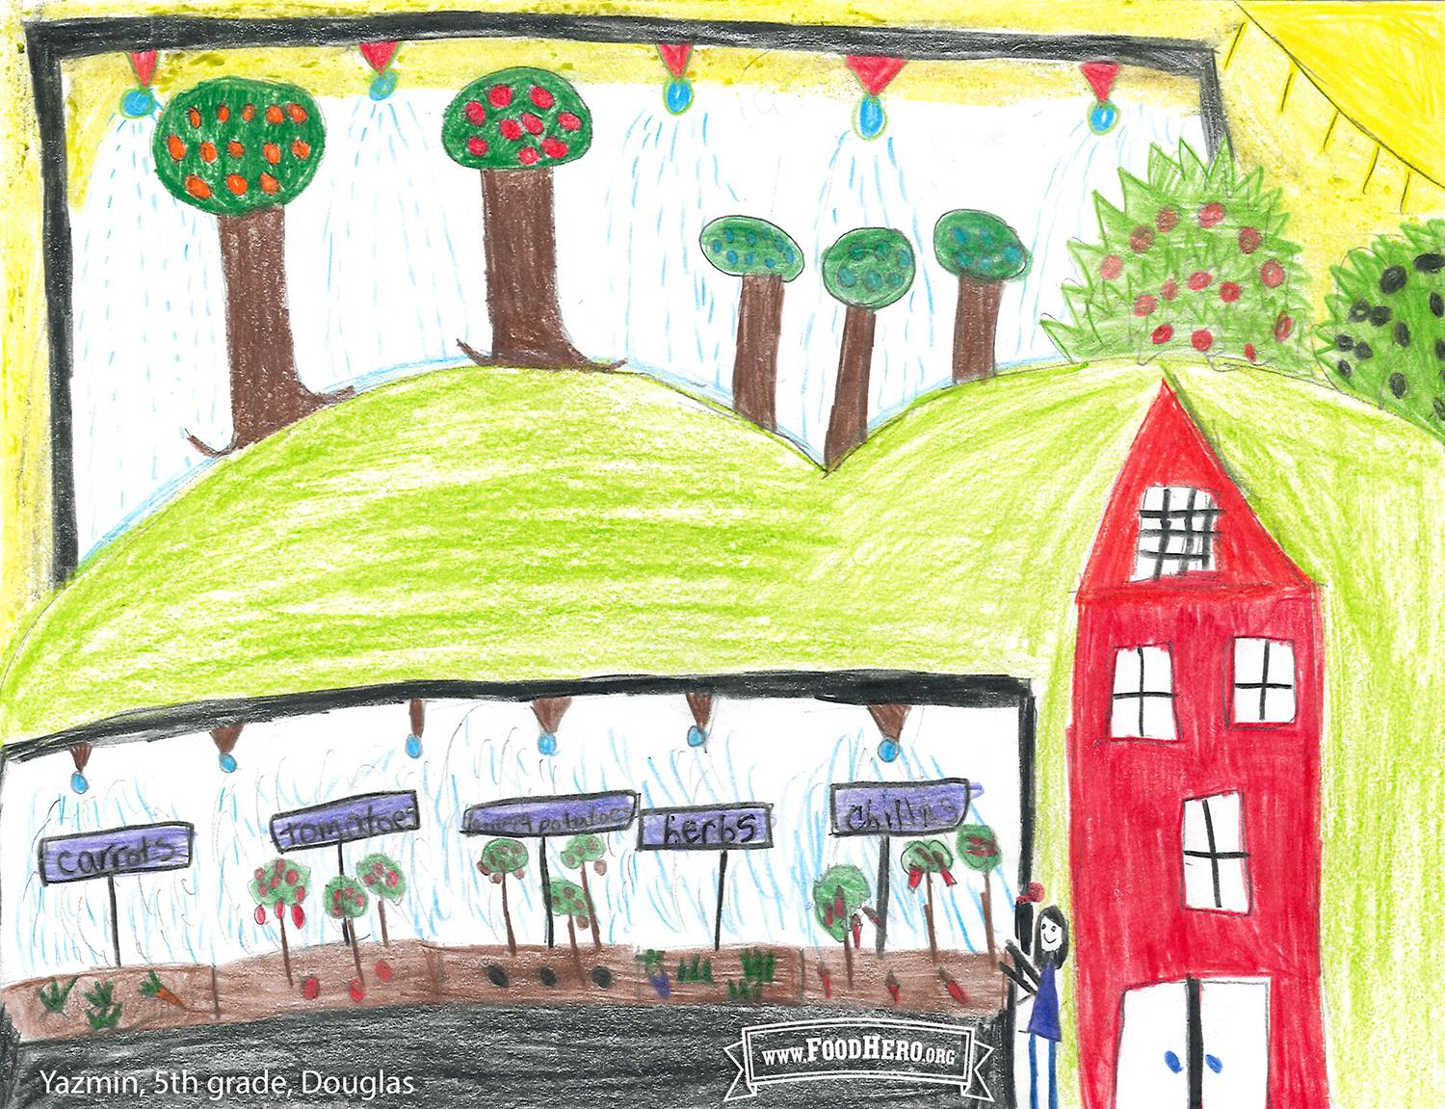
The OSU Food Hero Campus team will review winning entries that have a signed parent consent form. Winners will receive a Food Hero Champion Award and a reinforcement from Food Hero.

Last year’s winner from Douglas County can be found on the Food Hero Facebook page to help promote April Harvest of the Month – Herbs and Spices.

OSU Extension & Experiment Station Communications Model Release
I authorize Oregon State University and those acting pursuant to its authority to: (a) Record my image and voice
on videotape, audiotape, film, photograph, or in any other medium; (b) Use my name, image, voice and biographical material in connection with any such recordings; (c) Publish, exhibit, adapt, exploit, reproduce, edit, modify, make derivative works from, distribute, display, or otherwise use or re-use such recordings in whole or part without restrictions or limitation for any educational, promotional, fundraising, informational, or public relations use which Oregon State University and those acting pursuant to its authority deem appropriate. I waive any right I might have to inspect and/or approve the finished recordings or the use to which they may be applied.
I represent that I am at least 18 years of age and that I have read the above and fully understand it and I am knowingly and voluntarily executing this consent without compensation to myself.
Name _________________________________________________________________________________
Address _______________________________________________________________________________
City______________________________ State_______ ZIP____________ Phone_____________________
Signature____________________________________________________ Date_______________________
Parent/Guardian signature (if subject under 18) _________________________________________________

This material was funded by USDA’s Supplemental Nutrition Assistance Program (SNAP). SNAP provides nutrition assistance to people with low income. SNAP can help you buy nutritious foods for a better diet. To find out more, contact Oregon Safe Net at 211. USDA is an equal opportunity provider and employer.
Oregon State University Extension Service prohibits discrimination in all its programs, services, activities, and materials on the basis of race, color, national origin, religion, sex, gender identity (including gender expression), sexual orientation, disability, age, marital status, familial/parental status, income derived from a public assistance program, political beliefs, genetic information, veteran’s status, reprisal or retaliation for prior civil rights activity. (Not all prohibited bases apply to all programs.) Oregon State University, Oregon State University Extension Service is an Equal Opportunity Provider and Employer.

