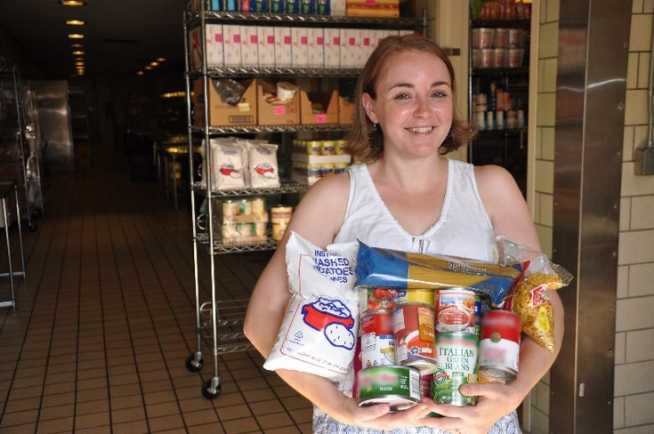
Sign Up Today:
Be a Food Hero
Pantry
Project
Volunteer

Examples of Volunteer Duties:
- Attend a training session.
- Obtain a food handler’s card (fee covered!).
- Pick up a pre-packaged supply box.
- Set up a demo table and serve tastes of Food Hero recipes at a food pantry.
- Return the supply box to be cleaned and
re-packed for next time.
Where: We are at all 9 Tillamook County food pantries! Contact us for more information on hours, duties, and location.
To Register: Call or email Grace Corry, at the OSU Extension office: (503) 842-3433 or grace.corry@oregonstate.edu

Tillamook County’s Pantry Project directly serves our community!
Our Volunteers:
- Serve food samples at all 9 Tillamook County/Oregon Food Bank Pantries.
- Encourage healthy eating through the sampling of recipes from foodhero.org.
- Exchange ideas with pantry shoppers about low-cost ways to cook tasty meals.
- Make new friends!

