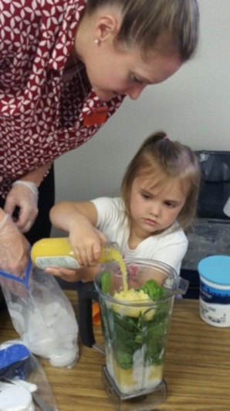**What: MyPlate for My Family** cooking classes are a great place to get new ideas for tasty, healthy, low-cost meals.

**Where:** Sunset Elementary School cafeteria,   
300 E Catherine Ave, Hermiston, OR 97838

**Dates:** Tuesdays, November 7, 14, 21, and 28

**Time:** From 5:30 -to7:30pm

**Who:** Adults with their children ages 5 and older.

**Language:** Classes will be taught in English   
with Spanish interpretation.

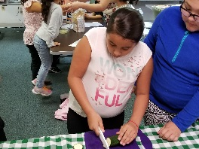**To Register:** Call Oregon State University Extension at **541-567-8321** or Hermiston WIC at **541-667-2545**  
 **MyPlate for My Family classes include:**

* + a chance to prepare and try healthy recipes.
  + tips to save time and money on family meals.
  + basic food safety information.
  + ways to include more fruits and vegetables in your family’s meals and less fat, sugar and sodium.

